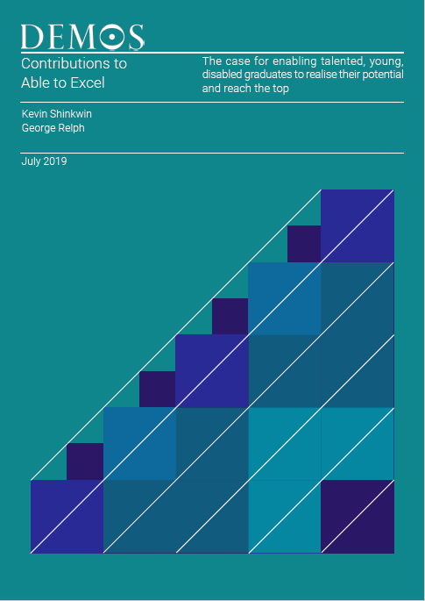

**Contributions to ‘Able to Excel’**

The authors of ‘Able to Excel’ are very grateful for the following written contributions to the paper. We have split the contributions into those from individuals and those from corporates; each set of contributors had three questions to answer, which we have listed at the start of each section.

The contributors are:

**Individuals**

Jonathan Adams (Paralympian); Dr Hannah Barham-Brown (GP); Abbi Brown (Advertising Executive); Sophie Christiansen CBE (Paralympian and Software Developer); Helen Dolphin MBE (Entrepreneur and Transport Expert); Neil Heslop OBE (Charity Chief Executive); Derek Hirst (Transport Consultant); James Lee (Consultant); Mark Ormrod (Motivational Speaker, Peak Performance Coach and Author); and Susannah Rodgers MBE (Paralympian and Company and Charity Director).

**Corporates**

Abode Impact; BBC; Enterprise Holdings; EY; King’s College London; Marks and Spencer; Andy Street, Mayor of the West Midlands; MyPlus Consulting; RBS; Ricorda Consultancy Ltd; Unilever; and the Valuable 500.

**Individuals**

1. How important is it that we use the 25th anniversary of the DDA as an opportunity to put disability back on the agenda?
2. What non-workplace barriers have you faced in your career and what impact did they have?
3. On the basis of your experience, what one thing would you most like to see done to remove non-workplace barriers within the next 10 years (i.e. by the 35th anniversary of the DDA)?

**Jonathan Adams** is a Paralympian.

****In 2019, 24 years after the DDA, disability is still not on the mainstream agenda. There is still a strong divide between disabled and non-disabled people. I feel both of these are due to a lack of understanding about what it means to be a disabled person in a non-disabled society.

Harmful portrayals in the media and an outdated understanding of many conditions has created a disconnect, completely separating peoples’ perceptions of disability from what disability actually is.

The disconnect is so damaging because it results in a lack of genuine urgency in making society work for disabled people. The barriers that disabled people face are real issues facing real people, but they cannot properly be tackled until disability is at the forefront of the agenda.

In a modern society that is evolving so quickly, it is unacceptable for disability to be lagging so far behind. We have to ensure that, irrespective of a person's individuality, everyone has the right to be included, valued, and treated as an equal member of a free society. To achieve this, it is imperative that we bring the vision of the DDA – social justice and equality for disabled people – into the modern context.

The biggest barrier for me was in higher education, a vital stage many go through before embarking on their careers. Due to my disability, I was never perceived as an equal by my peers or the staff. This not only had a catastrophic effect on my experience at university, but a lack of support also meant I was unable to get the right qualifications to pursue my chosen career.

My experience also robbed me of my confidence that I could succeed. Before people can pursue their ambitions to get a job, they need confidence in their ability. The education system plays a large and necessary part in fostering this confidence and individuals’ ambitions. Without a compassionate and open approach, however, this can’t be achieved. With the right support, I was a confident and articulate student, and I know I could make a positive contribution to the workplace, but my condition was not consistently understood and, as a result, I now can’t get a foot in the door with employers.

Disability – and disabled people – are currently seen as an extension of society, rather than an integral part of it. In this respect, it is so important that non-disabled people understand what it means to be disabled in a non-disabled society, so that we break the disconnect between disability and how people perceive disability. The best way to do this is to promote an accurate, genuine, and representative notion of disability.

Currently, disabled people are under-represented in politics, in corporate boardrooms, and in social discourse, and this means our interests are only represented when non-disabled people choose to represent them. Until disabled people begin to occupy influential positions, and start to represent ourselves as an active and integral part of society, lasting change to the culture around disability seems impossible.

**Hannah Barham-Brown** is a GP and BMA Council Member.

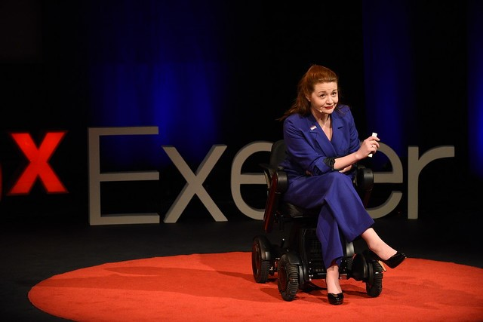As we approach the 25th anniversary of the Disability Discrimination Act, it is hugely disappointing that we still have such a long way to go to end discrimination, let alone to promote real equality. While 13.9 million people in the UK have some form of disability, we are still seen as a novelty in the workplace, and often left out of conversations at the very highest levels of society, or at best, thrown in as an afterthought as part of a tick box exercise. We need to change the narrative around disability from being one of problems to how disabled people are in fact an asset to the workplace and society, bringing with them a unique range of skills honed from years of living in a society designed without us in mind; if you want a ‘problem solver’, employ someone who has daily struggles with the London transport networks – we have a LOT of experience in working out efficient solutions quickly!

Barriers to my working are many and varied – transport to work, particularly when I lived in London, was so inaccessible my journey could easily take twice as long as it took an able bodied person; and yet the Freedom Pass still doesn’t work on trainlines before 0930, so you’re charged for the privilege of travelling double the distance to work. I’ve worked in NHS facilities where the clinic rooms are upstairs or have doors too narrow for my wheelchair. Where simple things like reaching the equipment I need for a procedure is spread across multiple shelves that are too high for me to reach from my wheelchair. Moving jobs every 4-6 months as a junior doctor often requires multiple occupational health appointments; and in a profession where everyone feels they need to be ‘superhuman’, a regular reminder of all of the ways in which your body works against you is not great for the mental health.

I would like disabled people to be involved in every level, and in every conversation about access and employment for all. The most frustrating element of being disabled in employment is when able bodied people assume they know what I want or need, and by the time I am brought into the conversation, well-meaning mistakes have already been made. I want role models, people like me in senior roles who give me something to aspire to. Constantly being the one to break the glass ceiling is frankly exhausting; both as a woman and as a disabled person. It’s hard enough having the self-confidence to believe I can get to the top levels. I shouldn’t have to convince other people too.

**Abbi Brown** is an award-winning advertising executive at AMV BBDO.

Putting disability back on the agenda for the 25th anniversary of the DDA is enormously important. Whilst it’s important to acknowledge that lots of things have changed for the better in the past 25 years, hundreds of thousands of disabled people in the UK are still struggling to get access to the basics: suitable wheelchairs, appropriate housing, and education.

I recently moved to Whitechapel, right to the centre of what’s supposed to be one of the most diverse, inclusive, well-connected cities in the world, but every day I am made to feel isolated and excluded by the lack of accessibility around me. I live within ten minutes’ walk of three different tube stations, but I can’t get into any of them. I live fifteen minutes’ walk from a major UK train station, yet I regularly struggle to get onto any of the trains.

I’m 26 years old; the DDA has been around for nearly as long as I’ve been alive, yet four in ten disabled adults are unable to access their local shops due to inaccessibility. The ADA is only three years older than the DDA, but’s is almost universally enacted*.* If the US can properly enforce their disability discrimination laws, then why can’t we?

Outside of the workplace, the biggest barriers in my career have been public transport and accommodation. Like many of my friends from university, my first job after graduating was based in London; but whereas my peers could easily move into flatshares or sleep in spare rooms until they found their feet, it took me weeks to find a flat which I could physically access. Even then, there was a step into the flat, meaning I had to get out of my wheelchair and tip it up to get inside. I’ve since had to move house three further times, and each time I move I not only have to spend weeks or months finding a home I can live in, I also have to work out which local shops and public transport networks I can reliably access. Choosing an accessible route regularly makes a journey twice as long as the inaccessible option. On top of that, I always allow 30+ minutes extra time for any journey in case there’s a broken lift, or a bus driver refuses me access. My disability means that I have less energy and less muscle strength than my peers, yet it often takes me significantly more time and effort to travel to and from work or client offices than it would if I were non-disabled.

Ironically, my parents only live 30 minutes from Euston on the train. Life would have been much easier if I could have lived there for my first year or so of work, but their local station is inaccessible.

The most important thing for me is accommodation. Currently, many disabled graduates are forced to continue living in their parents’ homes, or in the county in which they grew up, because it’s simply too difficult to relocate.

It needs to be much easier for young disabled people to find accessible, affordable homes on the private rental market. I don’t believe this is just down to dedicated charities or local government; private landlords and letting agencies also need to be better trained in the DDA, and in how they can help disabled renters find appropriate accommodation.

**Sophie Christiansen CBE** is a Paralympian and software developer at Goldman Sachs.

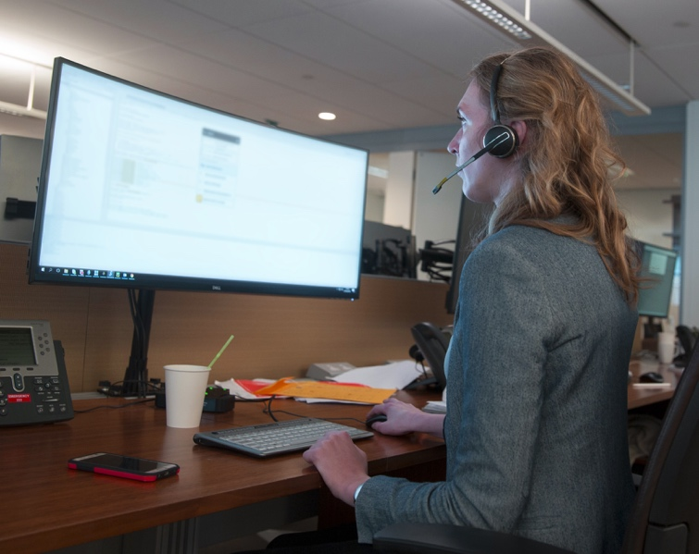

When I graduated from university I applied for every graduate scheme under the sun. On my CV, I had a first-class Masters degree in mathematics and, at the time, two Paralympic gold medals. But out of the endless applications I only got through to one interview round.

Was it this hard for every graduate? Was it my lack of work experience (for which I thought I had the pretty good reason of being number 1 in the world in my sport)? Did I miss that crucial key word in the applications? Or was it because I had disclosed my disability? I got no feedback from any of the companies.  
  
I disclose my disability at an early stage because, let's face it, I can hardly hide it at interview stage. But so many people don't disclose their disability, some maybe never, because they are scared it'll put them at a disadvantage, and after my experience, I can understand why.

In the end, I got both my jobs through contacts. My sport enabled open conversations about flexibility and extra needs. But what if I hadn't known those people, or didn't have gold medals to my name?

Companies have a responsibility to take that fear away from potential applicants. My suggestions would be ensure their application process was accessible to all, advertising within the disability community, enabling flexible working and emphasise the importance of having an open dialog where employees feel comfortable to talk about their disability. Not to mention an accessible workplace!

Disabled employees bring so much extra to businesses! Living with a disability means that we have spent a lifetime “thinking outside-the-box” and problem solving with resilience and perseverance. The Paralympics inspire the nation, so surely having employees with disabilities can do the same for a workforce.

But there are other non-workplace barriers that people with disabilities have to go through just to get to work – a lack of affordable accessible transport and housing, persuading social services to grant enough funding for care, the expense of disability equipment like wheelchairs. I have regular issues commuting to work by train – not being able to get on the first train home like everyone else because I have to wait for assistance staff to be free, prolonging my 13-hour work day and taking away my independence. I would often end up being left on the train if it were not for kind passengers hailing down the guard who hadn’t been told about me, even after I’d spent time booking assistance in advance. The automatic ramps on buses are amazing and make me wonder why trains don’t have them. But what if my only option was the mostly-inaccessible tube? Who would pay for a taxi?

It seems we are penalised for the more we want to do with our lives. And that’s the problem. It takes a very unique and driven type of person to do battle with all of this every day on their own. Should there be more one-on-one support to get disabled people into work, to help work through removing these barriers? Should the government actually enforce the DDA on inaccessible buildings and help bring train companies into the 21st century?

What makes me sad is that the DDA shouldn’t have to be enforced. Businesses should think about all their customers – it makes business sense! One day I hope the UK doesn’t think twice about disability and these barriers become a thing of the past, so that everyone can have equal opportunities and live life to their true potential.

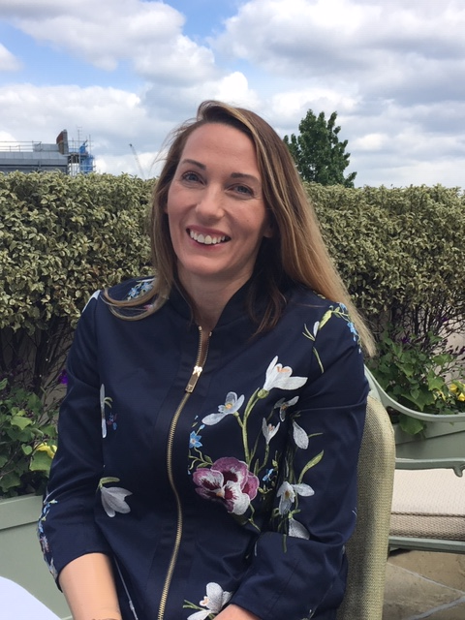**Helen Dolphin MBE** is a well-respected expert on transport and mobility. She runs a parking accreditation scheme called People’s Parking.

2020 is an important year for disabled people. On 8 November it will be 25 years since the first significant piece of anti-discrimination legislation for disabled people, the Disability Discrimination Act (DDA) 1995, became law. Anniversaries provide an opportunity to reflect on progress, and to take stock of challenges now and in the future. If this upcoming anniversary provides an opportunity to renew and re-fresh the agenda and set out the next steps in pursuing the goal of breaking down the barriers that isolate and exclude disabled people, then it should be grasped with both hands.

I would like to start my answer to this question by saying what a fantastic scheme Access to work is and without this scheme I am not sure I would have ever gone back to work after becoming disabled. However, there is often a lack of understanding among employers about the scheme and of the support provided, so there is a need for more education about how this scheme works. Access to work was also very difficult to access as a self-employed person and I felt like giving up on the application process as so many obstacles were in my path.

Socialising with your colleagues is an important part of any career. This has always been difficult as often pubs and restaurants are completely inaccessible for wheelchair users. It became a standing joke at one workplace that the least drunk person would have to carry me down the stairs at the end of the evening. One charity where I worked which was for disabled people organised a night out at a restaurant only accessed by a flight of stairs.

Having to travel on public transport has sometimes been a barrier, as the unreliability of assistance on trains has made me miss meetings. It makes me feel as though my career is not as important as others’; that there is an assumption that disabled people don’t need to go anywhere in a hurry.

I really hope within the next 10 years that all commercial buildings become accessible to disabled people. Unfortunately, the Equality Act 2010 has not made businesses comply and so instead I would like something added to business licence requirements to at least made them consider what they would need to do to ensure disabled people could enter their premises. This could be done in a similar way to food hygiene ratings, so five stars would completely accessible, staff trained in disability awareness, accessible toilet etc., whereas one star might be a portable ramp. Business rates could be flexible to accommodate for the size of different businesses and the costs involved in certain adaptations. Businesses who continue to be inaccessible would be rated 0 stars and should be closed until they make the necessary adjustments. Clearly some businesses that were upstairs may need to be granted some exemption, but they would need to demonstrate they were meeting other requirements and providing their service in an alternative way.

**Neil Heslop OBE** is the Chief Executive Officer of Leonard Cheshire Disability.

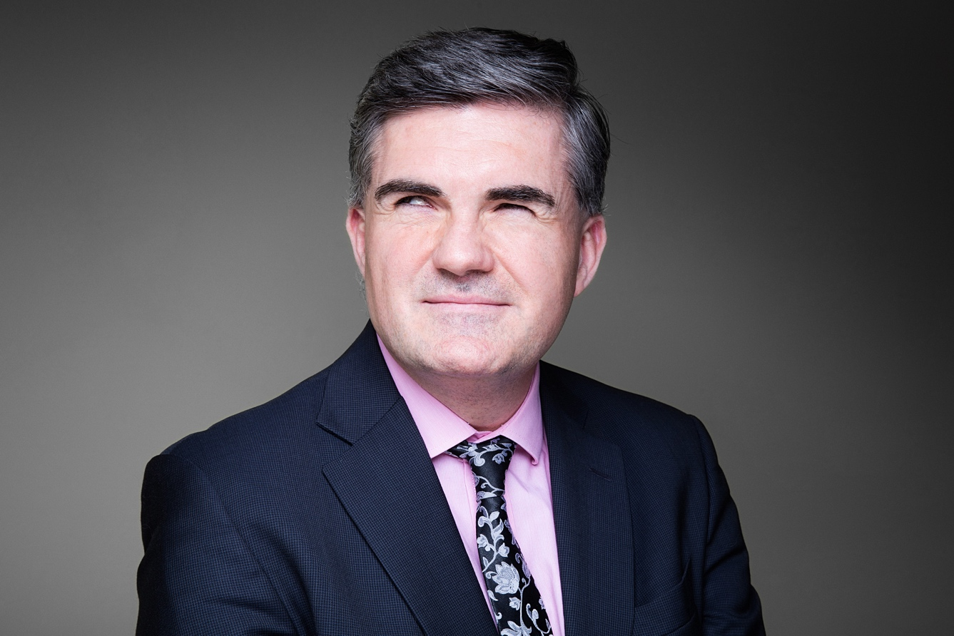

The 25th anniversary of the Disability Discrimination Act (DDA) should have enabled us to celebrate transformation in the lives of people with disability. In the nineties, as a blind man in his twenties, pursuing a telecoms career, I faced many barriers to realising my potential. I co-founded a charity - Blind In Business, to help others into work. Our first chair, Emma Nicholson MP, arranged for me to support the Minister for Disabled People by advising from lived experience, as the DDA was formed. The Act sought to put disability on the agenda and it should have ushered in seismic change for disabled people, removing barriers and enabling them to reach their full potential. Yet sadly, the arduous fight for employment equality must continue. With the disability employment gap remaining unacceptably high at almost 30%, so much remains to be done. [1]

It is clear that most disabled people are not yet receiving the right support on their journey to, or throughout their working life, leading to over seven in ten disabled adults in the UK falling out of work, due to their health condition or disability.[2]

Entrenched misconceptions amongst employers persist. Despite protections offered by the DDA, 24% say they would be less likely to employ someone with a disability[3] citing doubts about the ability of disabled people to cope with a job and concerns about the cost of workplace adjustments.[4]

Barriers like inaccessible transport infrastructure prevent disabled people from flourishing in work, with 35 per cent of disabled people experiencing problems using trains in 2017-18.[5] For many this makes the difference between pursuing or missing out on jobs.

25 years ago, I played a minor role in the development of the DDA and while it was a seminal moment in the fight for the rights of disabled people, all of those in power must re-double our efforts to turn its hope into practical reality for the millions who deserve better.

For me, some visionary business leaders gave me a break. Invested in supporting me, and thanks to opportunities presented by new technology, I became a CEO in telecoms boardrooms in the USA and UK. The dignity, financial security and independence I have enjoyed as a result must become available to all.

Legislation, including the DDA and the Equality Act, demonstrate how successive governments have attempted to tackle disability discrimination. Yet if sustained change is to take place, a joined-up, cross-departmental cultural revolution is needed.

Sharing best practice and targets relating to disability rights across Government would help tackle the entrenched discrimination disabled people face from transport to housing, welfare to social care, enabling them to pursue opportunities with confidence. The Minister for Disabled People should not sit siloed within the Department for Work and Pensions but genuinely work across all departments, overseeing a comprehensive disability strategy.

Throughout my career I have seen and experienced important positive changes in the way disabled people are treated in society and the workplace, yet the anniversary of the DDA must bring disability issues to the top of the political agenda as never before. Now, as CEO of international pan-disability charity Leonard Cheshire, I, like all of us must dedicate ourselves to play a part with businesses and government, in the partnerships needed to build the inclusive world promised by the DDA.

**Derek Hirst** is an independent consultant who gained his chartership with the Institution of Mechanical Engineers and has been involved in the Automotive and Rail industries.

Young disabled graduates can only fulfil their professional potential if a rail network is provided that is truly joined-up and accessible – one that meets all user needs, especially when coupled with the additional pressures and demands of work.

It is not just the requirements for tactile paving, clear signage, and unambiguous announcements, but the ability to be as flexibly accommodating as one needs to be in the workplace to meet deadlines, attend meetings that over-run, or just to socialise and network. Career progression should not be dictated by additional restrictions on the daily commute.

Having worked on metros in both London and Sydney, I have found there is now a strong drive to improve accessibility across the board: newer metro systems and modifications to older networks frequently provide step-free routes between the street and the train ‘as standard’ together with other accessible and inclusive improvements, but in many remaining legacy systems this is not the case. On the UK mainline, accessibility is not a given and pre-booked assistance is recommended. This results in the potential for ‘failed’ journeys because of the reliance on people or systems beyond one’s control.

In contrast, my involvement with HS2 has led to the delivery of a strategy that supports an aspiration for ‘independent access for all, from street to seat’. During this work, I considered user needs against the requirements in the regulations – and found the standards lacking in a number of areas. The Inclusivity and Accessibility Strategy therefore addresses these deficiencies and steers HS2 towards delivering an *inclusive and accessible railway*, not just one compliant with the minimum requirements.

For the anniversary of the Disability Discrimination Act, it is important we take a retrospective look to see how far we have come and gauge our progress: whether there are any issues and what we are doing to resolve them; learn lessons for continuous improvement; and consider how advances in technology, attitudes and other legislation affect our future goals.

My personal view is that we have made some good initial progress to removing accessibility barriers within public transport, and although it has taken a while to gather momentum, things are starting to happen. However, I also feel that there needs to be a clearer overall view of our ultimate aims and the route to achieve them. I therefore believe that there should be governmental endorsement to define and deliver a **short-term strategy** to provide a public rail system that has no accessibility failures and/or failure points, and that this should be delivered within an overall goal (and, indeed, will support the delivery) of a **longer-term strategic framework** that delivers equal, independent, and accessible journeys for everyone.

The first, short-term goal should be a consolidation of existing initiatives, enabling and encouraging greater use of the rail networks – supporting a trend that is already emerging. The longer-term aim is a greater stretch and it is acknowledged that there are costs, disruptions and complications involved. However, these are just the obvious issues: it is imperative for the development and delivery of these strategies to focus on user needs –not just the minimum requirements in standards – as ‘inclusivity’ and ‘independent access’ are currently not defined.

These challenges should be urgently addressed, not postponed indefinitely or caveated behind the Equality Act’s ‘unreasonable to do so’ get-out clause. I hope that by the time we are celebrating the golden anniversary of the DDA we are also reporting on how the UK grasped the nettle and is now enjoying and reaping the benefits of a fully accessible rail network.

**James Lee** works as a consultant across the public, private and voluntary sectors on matters of equality, diversity and inclusion.

Cast your mind back to the 90’s and some of the significant events which would shape our world for years to come. What springs to mind? Perhaps the launch of the World Wide Web; the Rodney King verdict and subsequent race riots; the adventures of six young Friends living in New York?

One event which went unnoticed by me at the time, but which would go on to have the singular most profound impact upon my world, was the passing of the Disability Discrimination Act in 1995.

The Disability Discrimination Act made it unlawful to discriminate against disabled people and enshrined our right to fair and just treatment in several important areas of life, and with its 25th anniversary fast approaching, this seems an appropriate juncture at which to ask the question (in the words of that other great thinker, Joey from Friends): “how you doin’?”

The answer, sadly, is not great. Disabled people are more likely to be placed in a segregated education system; more likely to be excluded from school; less likely to obtain any kind of qualification; less likely to be in work; when we are in work we earn less than non-disabled people; we are more likely to live in poverty; we have a significantly reduced ability to access public transport infrastructure and there is a real lack of suitably accessible housing available too.

Like many disabled people living in Britain today, I have experienced many of these barriers myself. Whilst I recognise the benefit that some children get from being placed in a more specialist setting, I found my mainstream education to be a crucial part of my development. I was never more than an average student but had the good fortune to end up attending a very good university: an opportunity cut short when I was subsequently forced to leave as my mobility deteriorated and I found myself unable to travel to and from university.

Armed with no more than a handful of A Levels, I eventually managed to find work after years of volunteering. Although my mobility impairment led to challenges within my working environment, it is the barriers outside of work which have created the greatest obstacles to my career progression. For example, I have to allocate an extra hour of time to every work-related journey and plan back-up, step-free routes with military precision in case of a disruption to the public transport network: disruption is inconvenient to all but can be fatal to the plans of disabled people. This is an issue that is particularly exacerbated for many of my disabled friends who live in more rural parts of the United Kingdom.

And an accessible transport network can only be built upon the all-important foundation of access to good quality, affordable housing. This is true for all people, but especially important for disabled people, given the barriers we already face in so many other aspects of life. My own struggles to find accessible accommodation have seen me turn down opportunities for paid work and career advancement, as my precarious housing situation offered no stability for the hours I would need to put into my professional life.

Although the legislative framework is in place to promote equality, the failure to realise the DDA’s vision shows that the real challenge lies in the implementation of the law or, as Tolstoy says, governing. There is a popular saying in the disabled community: “nothing about us without us”. If we are going to make progress on the removal of barriers that disabled people face, then we must be part of the conversation and architects of the solution as leaders in public office and the private sector.

If disabled people are included and represented, and if we can share the responsibility for leading change together, perhaps we might find that governing for everyone is not so difficult after all.

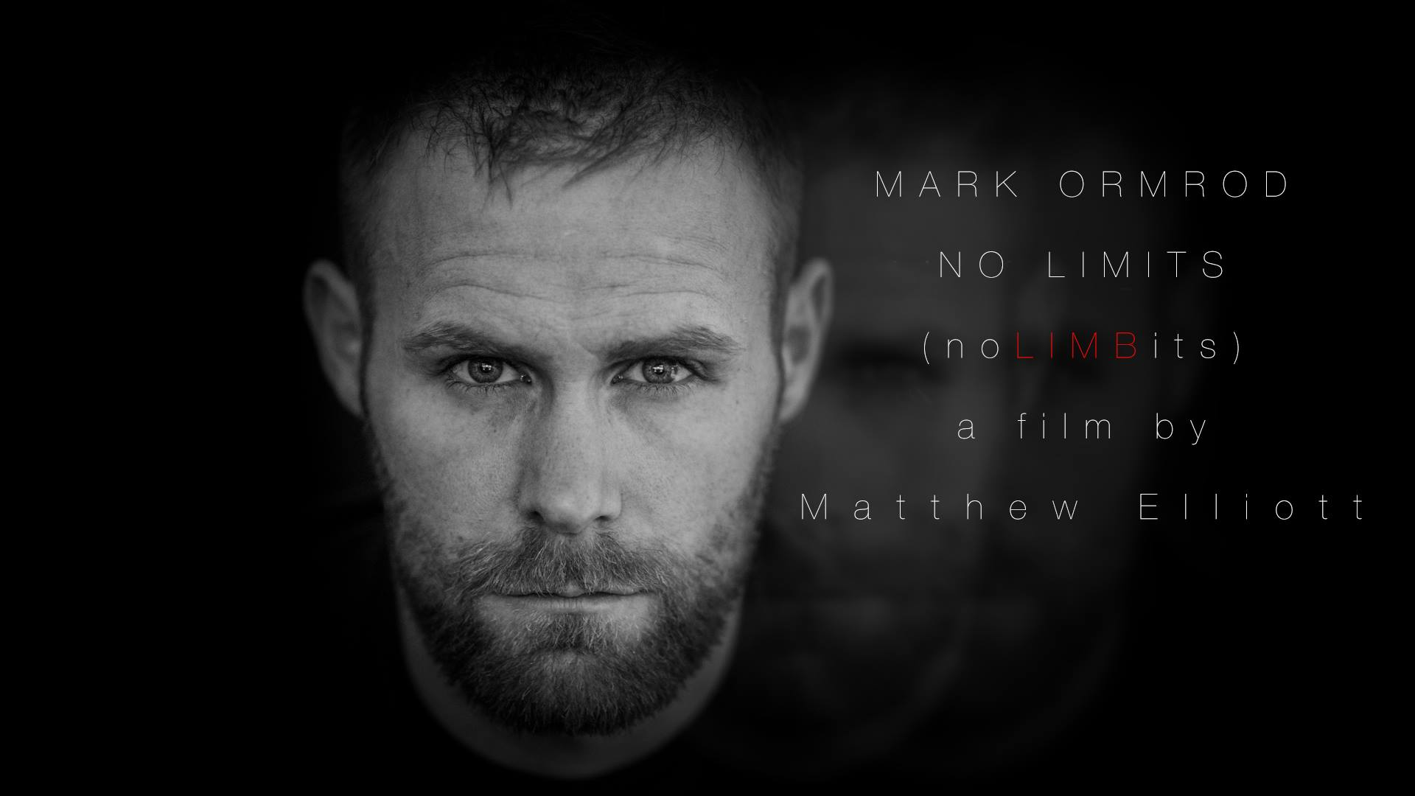**Mark Ormrod** is a veteran, motivational speaker, peak performance coach, and author.

I think with it being the 25th anniversary and in effect a milestone occasion for the DDA, then it is the perfect opportunity to highlight the fact that whilst many things have changed for the positive in those 25 years, there is still a lot that needs to happen to ensure that disabled people are given a fair roll of the dice and opportunities that are equal to non-disabled people in the same circumstances.

I think I have been very lucky in that the Royal Marines have looked after me and my family very well, and I honestly don't think we could have asked for more. But, I am aware that many other disabled people in my situation aren't as fortunate. Housing, employment, education, disabled adaptions, leisure and everything in between can be a struggle for someone with a disability but with the right support and guidance these issues can be address although the process can often be very frustrating, stressful, and demoralising.

I think there needs to be tighter control on who is entitled to a blue badge. I'm aware that not all disabilities are visible and you can't judge everyone just by looking at them, but I very often see people like myself with mobility problems forced out of disabled parking spaces for people who seem to be able to just park up, get out, and then stroll off about their business and from the outside it seems their mobility is fine. There seems to be a lot of abuse of the system, which means that people who need to use their badges to park close to their place of work lose out.

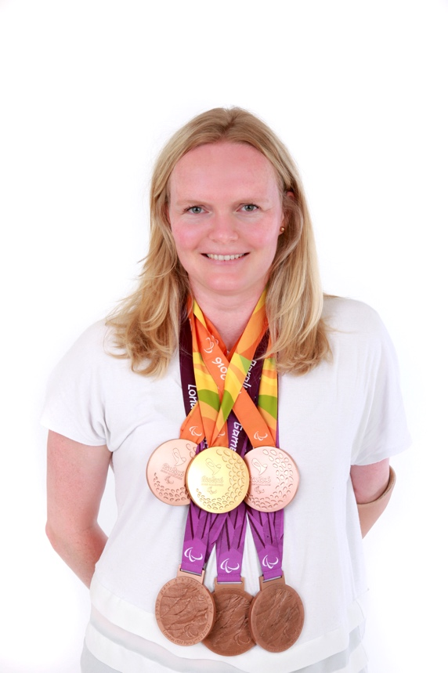**Susannah Rodgers MBE** is a Gold-medallist Swimmer from the Rio 2016 Paralympic Games and Bronze medallist from London 2012. She is a company and charity director, advisor, and a Young Global Leader with the World Economic Forum.

The movement and discussion around disability is growing rapidly, but it remains vital to shift and challenge perceptions around what it means to be disabled. In the 25 years since the DDA, there are still challenges faced by many disabled people on a daily basis. Physical access is still a big problem, provision of Changing Places facilities, equal opportunity in jobs and education; these are just a few of the challenges. Even for myself, due to budget and NHS constraints, I don’t have access to parts (knee joints and prosthetic feet) for my leg that would make my life considerably easier. And, unfortunately, where progress has been made, there is still a significant postcode lottery – or even a disability lottery – with uneven approaches to disability throughout the country and government policy.

However, I do believe that the dialogue is shifting in this country and although sport is not the sole answer, there has been a shift since this country hosted the London 2012 Paralympic Games. We are slowly moving in the right direction. What we need to do now is up our game and place disability firmly on the agenda with a renewed sense of urgency.

I have always worked and never been on employment benefits. Despite having a very restrictive impairment, I want to be independent, I want to contribute to society and to the economy, and I want to be living the life I choose to lead. Without work, I would feel I had no purpose. However, London is a very tough place to live if you have a disability; it is rough, pushy, aggressive, commutes are hard, people fly around you and you have to keep up with the pace.

I choose jobs based on their location rather than what I would ideally like to be doing. There have been roles I would have loved to do but have had to rule out because the commute required more than one change on the Underground. If there is no easy route, I will turn the role down. I have lived all over London and every time, I have tried to match where I live with the potential commute to a role. This is the most significant issue I face.

I completely support flexible and remote working. That way, you can come in when you need. However, companies and organisations are still lagging behind in their thinking around this because of trust issues. I think one or two touchpoints in the office per week is enough to keep a team going. Sitting chained to a desk nine-to-five, five days a week seems unnecessary to me in the digital age.

We all have wifi access, we are all connected wherever we are, so why are we still all slaves to commuting? This could benefit not just disabled people, but also people with young children, working mothers, and many others. We need to end the stigma around remote working that it is in some way worse than being in an office.

**Corporates**

1. How important is it for business to use the 25th anniversary of the DDA to put disability back on the corporate agenda?
2. What are you doing now or planning to do to create the right conditions for disabled employees to realise their potential, reach the top of their professions, and maximise their contribution to the success of their businesses?
3. In return for business doing its bit, what one Government measure aimed at removing non-workplace barriers (as above) would enable talented, young, disabled graduates to most benefit from what employers are already doing in the workplace?

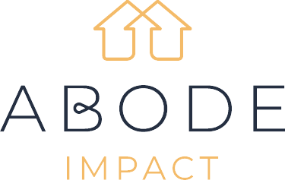**Abode Impact**

Disability will affect all of our lives at some point.

Almost 1 in 5 people (19%) in the UK are disabled and only 17% of those people were born disabled. The majority of these people acquired their impairment later in life1. The disabled community are a large and growing percentage of our population.

The Disability Discrimination Act (DDA) was established in 1995; 25 years on and it is even more important to put the DDA back on the business agenda. Disabled people still face barriers to accessing the private housing, employment and consumer markets; and these markets are not benefitting from the value disabled people can contribute.

Abode Impact specialises in rental homes for people with accessible housing needs. We hear stories daily of wheelchair users looking for suitable housing because there is an entrenched shortage of wheelchair accessible homes across the UK.

This problem is most acutely felt in the Private Rented Sector (PRS). Abode Impact surveyed 448 wheelchair user households and found that **4 in 5** respondents currently live in a home that does not fully meet their needs. **91%** had experienced barriers to renting in the PRS.

Living in an accessible home can significantly improve the mental, physical and financial wellbeing of wheelchair users. Notably, it increases access to employment: people with unmet needs for accessible housing are four times more likely to be unemployed or not seeking work.2

As it stands, the UK PRS is ignoring the accessible housing market and losing the purple pound. There are **1.8 million disabled people with identified housing needs**. **39% are in the top half of income distribution** for the population as a whole, indicating they could afford to privately rent an accessible home.2

About Abode Impact:

Abode Impact is launching an accessible housing fund for London. The fund will purchase wheelchair accessible homes for rent; the homes will be rented to people who require accessible housing features.

Abode Impact believes that living in suitable homes will positively impact disabled people and their families by:

* Improving mental wellbeing – reducing mental distress and depression3
* Improving stability – avoiding family breakdown caused by the strain of living in inaccessible accommodation3
* Reducing private spending on care

Furthermore, Abode Impact believes that by proving the investment case for an accessible private housing market to investors, developers, and Government, it can encourage a significant shift in the market for this type of housing - from niche and underserved to mainstream and sufficiently served.

The Government is already putting measures in place to support this shift. Abode Impact is in the late stages of agreeing support from the Mayor of London through his Innovation Fund, to bring forward a program which will see hundreds of affordable accessible units being made available for Londoners in the next three years.

We believe wheelchair users should be able to rent wheelchair accessible homes. Furthermore, we believe the housing market should benefit from the purple pound. Putting the DDA back on the agenda of business will help make this happen.

**Eleanor Bowden,**

**CEO of Abode Impact.**

1. Papworth Trust Disability Facts and Figures, 2018.

2. Habinteg and Papworth Trust, The Hidden Housing Market 2016.

3. Aspire and Loughborough University, 2016.

4. Scope’s Disability Perception Gap report, 2018.

5. GLA, 2015 London Plan.

**BBC**

Overview – the importance of diversity



As the national broadcaster, it is vital that the BBC reflects the nation we serve.  Our ambition is also to be the most creative broadcaster in the world and this includes reflecting the diversity of our audiences through the authentic perspective a diverse workforce brings.

We are already diverse, and more so than we ever have been, but we still have further to go. Our five culture and career progression reviews told us that while we were doing well in some areas, we need to make change more quickly and decisively in others to create a culture in which everyone can thrive.

We have stepped up our efforts with a detailed development programme to make this change, with a range of new actions that include introducing accountability for the whole programme at Board level. This is the widest and furthest reaching plan we have ever had - more ambitious than any other UK broadcaster.

Progress on disability diversity at the BBC

* The BBC reached its 8% 2020 workforce target for disability ahead of time.
* Our current figures for workforce disability (published in summer 2018) are 10.4% for our workforce and 9.5% for our leaders.
* In November, the BBC’s review into disability culture was published. One of its main recommendations, accepted by the BBC Board, was to increase its target for disability in its workforce from 8% in 2020 to 12% in 2022.

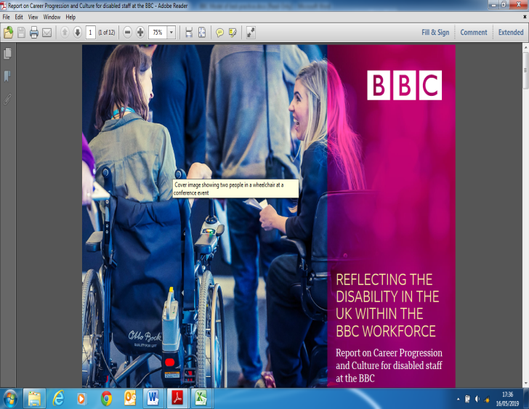

The BBC recently launched its most extensive piece of work to better understand the barriers faced by disabled colleagues relating to Career progression and Culture. The Disability Career Progression and Culture project was sponsored by Anne Bulford, Deputy Director-General and formed part of five programmes which set out to create a more inclusive culture across the BBC.

The aim of the project was to review career progression and culture as it relates to disabled staff; to identify best practice and make recommendations to the Executive Committee on how we can support the BBC to achieve its goals of ensuring disabled colleagues are able to thrive here.

Over 140 members of staff attended workshops, emailed us, took part in focus groups or one to one meetings.

Recommendations

Based on the feedback and the available data, a series of recommendations were devised which cover five key areas:

1. Raise the profile of disability through visible leadership and support;
2. Introduce an updated Disability leadership and workforce target of 12% by 2022 to better reflect the UK;
3. Make accessibility a priority across all of our policies, procedures and ways of working;
4. Build a sustainable pipeline of talent;
5. Raise awareness and create a disability friendly environment.

These recommendations are already being implemented. To date we have:

* **Designed and implemented a series of Disability focused training programmes which are mandatory for all staff -** working alongside our technology partners, we have already rolled out a new online module designed to provide staff with a greater level of disability confidence. We are also in the process of designing a new training offering to support managers who have specific responsibility for disabled staff. Each of our disability training initiatives will also compliment the additional material we are currently implementing to give all staff a greater understanding of Neurodiversity.
* **Redesigned our already successful Disability Development and mentoring programme called ‘ELEV8’which sits alongside our wider BBC mentor matching programme which our disabled colleague will be able to access to ensure that can further progress their career.**

One of the key success stories emerging from the ELEV8 programme in recent years has been the development of the innovative concept ACT NOW. Using mobile phone technology, ACT NOW provides managers with quick and easy access to online information concerning the support of disabled staff.

* **Appointed our Disability Lead specialist** who will support the business to drive the agenda forward, offering thought leadership and innovation for an inclusive workplace that is truly accessible to all.
* **Reviewed our leadership and development programmes along with our recruitment practices** to ensure we are fully accessible and inclusive to all.
* **Begun implementation of our disability adjustment passports** – this is a document which outlines the adjustment requirements and the implementations needed for our disabled colleagues who may be moving to a new department due to promotion or new opportunity or a new manager joining the team. The individual will determine who has access to this information and in a fluid and flexible market where colleagues are broadening their skills and experiences the adjustment passport is will ensure that our colleagues adjustment needs are in place prior to their arrival to a new role and their manager is aware of their needs, working alongside a number of other leading organisations, we are in the process of implementing these measure to help enhance the relationship between staff and managers and also allow staff to move more freely between roles.
* **Driven inclusion by gaining a better understanding of company demographics across our workforce population, accessibility needs and the barriers to career progression and culture**  – we have developed the information we capture within our company census concerning disability and reasonable adjustment provision
* **Improved current processes** by enhancing the accessibility of our premises to streamline our auditing capabilities and introducing a series of new design guidelines.
* **Increased our Disability targets from 8% to 12%**, which have been implemented across the organisation, work is currently underway to ensure we are creating a disability friendly environment that fully nurtures, grows, supports and develops disabled colleagues to reach their full potential at the BBC.

**Diversity Strand 31st March 2019 BBC Target**

|  |  |  |
| --- | --- | --- |
| **Disability (all staff)** | **10.2%** | **8%** |
| **Disability (Leadership - Bands E+)** | 9.1% | 8% |

The BBC would support any and all, government interventions that remove non-workplace barriers for talented and young disabled graduates to access the BBC as an employer of choice.

Due to the nature of our industry and the more than likely possibility that future employees will be required to visit or work at other locations across the country, affordable/accessible transport and accommodation are very important and a huge consideration for anyone seeking a career within the creative industries.

Minimising such barriers to our industry should see a growth in a generation of talented individuals looking to share their skills and vision. This will ensure we are telling the best stories, reflecting our audiences and future proofing our industry.

**Enterprise Holdings**

Managing disability in the workplace is an issue that should never have fallen off the agenda. Celebrating the 25th anniversary of the DDA is, therefore, an important moment for employers. We need to ask ourselves: “Are we doing everything in our power to ensure we create the best environment for employees with disabilities to do their best work?”

Disability is an issue that affects almost everyone. Many people will acquire a disability at some point during their working lives, and most are affected through family or friends. Current data also suggests as many as 80% of disabilities are non-visible. This means it may not be obvious to line managers and co-workers that an employee has one.

So, there are many reasons why it is vital that companies act to ensure all employees get the support they require to reach their potential.

At Enterprise, our focus on disability starts at recruitment because we want to make sure that everybody is able to show their best self. We talk candidates through what is required at each stage of the recruitment process, and then discuss how we can help them to perform to the best of their ability at each stage. We are proud to work with a specialist UK-based adjustment company, Microlink, to deliver what our candidates may need. While line managers always want to do the right thing for their team members, they may not know what is best in every circumstance and Microlink provide this necessary expertise.

We have just launched a Wellness Passport for all our employees, which includes information on disability as one point of reference for managers. For example, it could also be a question of style – I’m a morning person, I prefer smaller meetings. The employee takes their passport when they start a new position or get a new line manager, so knowledge on how they work best is carried through.

We are also pleased to have internal disability mentors and role models, to foster talent and promote the realisation of ambitious aspirations. Our disability group – THRIVE – runs events, especially around key dates such as Time to Talk and Mental Health Awareness Week to ensure the workplace is supportive for all. Everyone comes to work to shine, and we want to create the environment where this can happen.

We work closely with the Business Disability Forum and support many of its goals for improving opportunities for disabled people in the workplace.

Our key recommendations include:

* Raising awareness of what disabled people can/should expect when starting work to ease the transition from school/university, as students may receive a lot of practical support while in education which may not then be available in the workplace.
* Work with education providers to ensure careers teams know how best to support young graduates with disabilities. For example, many university careers services may not be equipped to answer questions such as “should I disclose my disability?”.
* The introduction of a ‘study to work’ passport or similar handover system held by the individual to help guide conversations with employers or occupational health on any required adjustments.
* Delay the end of insurance support via the Disabled Students Allowance (DSA) to cover some or all of the job search period, and connect DSA to the Access to Work scheme for seamless transition between study and work.

**Donna Miller, EU HR Director**

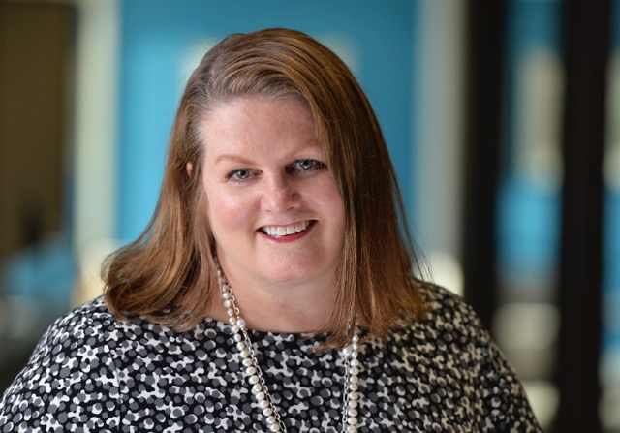

**EY**

****Any organisation committed to recruiting and retaining top talent – talent that will be working with them through our fourth industrial revolution – should be sourcing from the broadest talent pool. That includes people who consider themselves to have a disability. At EY we know we can’t be successful unless our workforce is made up of diverse talent, and all EY people are fully involved and engaged. Our differences make us better. Leveraging our unique strengths and capabilities makes us stronger.

We know from the World Health Organisation that 1.3 billion people live with some sort of disability. That is 15% of the global population and 1 in 7 people. The most interesting stat for an employer is that 80% of disabilities are acquired between the age of 18 and 64 years which is our working population. All that said, in a survey that EY ran for the #Valuable 500 campaign, which was launched at Davos this year, we heard that 56% of the C suite leaders that took part, said that the topic of disability rarely or never came up on their leadership agenda. So many organisations are focused on gender and LGBT+, some also on BaME, but too few on disability, despite these stats. There is absolutely no excuse for disability not to be on every leadership agenda.

At EY we are proud to confirm that we have signed up to the #Valuable campaign with the following global commitment to –

* Enable EY people to proudly bring their authentic and full selves to work every day
* Deliver an inclusive employment journey for EY people – from how we recruit to how we develop, retain and promote
* Provide a more accessible workplace through accommodations and accessible technology and building design
* Equip EY people with the skills and knowledge they need to be inclusive of people with disabilities

In some geographies we are early in the journey, but in the UK we have a vibrant Purple Champions programme for allies, we have an abilities network with a number of chapters focussed on different element of diversity such as stammering, autism, dyslexia and hearing loss and most important we have a strong Partner sponsor from our leadership team.  Something that I am most proud of at the moment is our fledging Asperger syndrome pilot that launched last summer with two successful placements in our Newcastle office.  We are now recruiting for two cyber roles in our Dublin office and anticipate more opportunities to follow.

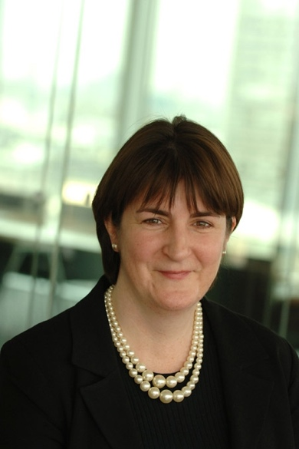Introduce a process (perhaps linked to Access2Work) that would facilitate/streamline the transition with technical devices and human support for graduates moving from university to work.

**Fleur Bothwick OBE, Director of Diversity and Inclusive Leadership EMEAI**

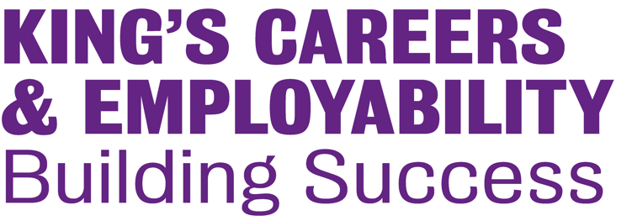**King’s College London**

1. Why did King’s initiate the Internship: Advance scheme and what reception did the idea get from employers?

Based on data we collected, we identified that there was a significant gap in the number of disabled students who were a) applying to our internships and b) successfully securing these. As a result, we worked closely with our Widening Participation department, Diversity and Inclusion team and Disability Advisory Service to set up an exclusive internship scheme called King’s Internships: Advance.

The idea was very popular amongst employers; particularly larger employers for whom disability was high on the agenda, but didn’t necessarily have specific provisions in place for disabled students/graduates.

1. What were the successes in the first run of the scheme last year?

The pilot year of the scheme was a great success overall. We partnered with top employers from a range of different sectors to offer a variety of internship opportunities and stewarded these organisations throughout the process in order to best support them, and the interns.

Feedback from participating interns and employers has been overwhelmingly positive. Out of the six students we placed as part of this pilot scheme, one was offered permanent employment and three were fast-tracked to the employer’s graduate scheme (there were no available opportunities for the other two students). 100% of the employers we worked with said they were very satisfied with how the programme had been run and 100% of the interns said that they had developed: confidence in applying for future roles; an awareness and/or insight into a particular role or sector; a better understanding of the labour market; and valuable work experience and skills that will bolster their CV and future applications.

1. What are the future plans for the scheme?

We are now into the second year of the scheme and have retained 100% of the original employers, as well as adding another huge brand. The immediate plans for the second year were to consolidate and improve the scheme. We have built even closer relationships with ‘King’s Disability Support’, who offer individual guidance to both the employer and the student.

The plan is to continue to steadily improve and grow the programme and to continue to grow the confidence and opportunities for disabled student at King’s.

**Marks and Spencer**



1. The 25th anniversary of the Disability Discrimination Act is a great opportunity for employers such as M&S to highlight the importance of inclusive workplaces for people with disabilities. At M&S, we have an active Disability Network led by employees with sponsorship from senior company executives, as well as a long-running employability programme which supports people with disabilities and health conditions. External milestones such as this are therefore important as they provide opportunities to educate colleagues and increase awareness, particularly with our line managers who play a crucial role in creating the right conditions for disabled people so that they can realise their potential.

2. We have a strong record in making adjustments to support disabled M&S colleagues and customers in the workplace. We monitor the proportion of colleagues in our workforce who have a disability or health condition and closely analyse their engagement scores so that we can see where further action may need to be taken to support employee wellbeing. In addition, we know that mental health is a rising issue amongst our employees and this is something we have been working on and will continue to pursue as a priority. For example, we are working closely with our Disability Network to provide support, develop tools and resources for colleagues and to increase education around inclusion and awareness of issues relating to disability or mental health.

In addition, M&S has had a dedicated employability programme, Marks & Start, in place for over 15 years, which provides training and work placements for people with disabilities and health conditions. In partnership with the organisation, Remploy, this programme provides bespoke support so that unemployed disabled people can acquire the skills and work experience they need to secure employment. Last year, we supported around 750 people with disabilities through this programme and approximately half of those who completed their placements moved into employment.

3. More broadly, M&S has been an active supporter of the Government’s Disability Confident scheme since 2016, as it aligns with our focus on inclusivity and removing barriers so that disabled people can fulfil their potential. However, we believe that the Government could do more to promote this scheme with other employers and encourage take up of the resources and support that is available, so that more businesses have the skills and confidence they need to recruit, retain and develop employees with disabilities and health conditions.

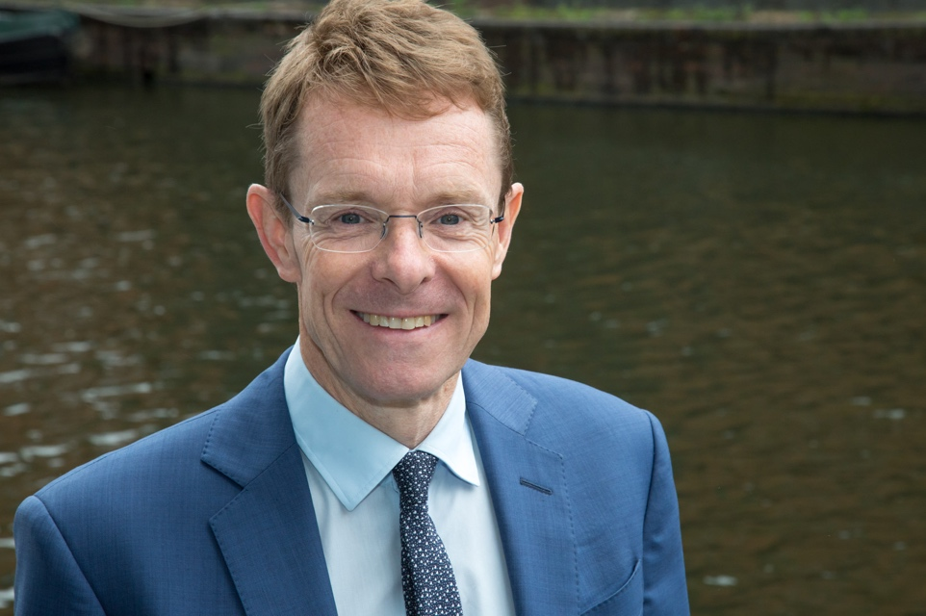**Mayor of the West Midlands, Andy Street**

The DDA’s 25th anniversary provides an important milestone to showcase best practice and renewed commitment to challenge the individual, organisational and societal mindsets over recruitment, perceived capacity and ability of disabled people.

When I became Mayor I launched the Leadership Commission and the resulting report, “Leaders Like Me”, told us that people with disabilities are underrepresented across the board in in the workforce as a whole and in leadership positions. Our Inclusive Leadership Pledge (www.wmca.org.uk/Pledge) is beginning to inform and influence change, but I recognise that this progress is compounded by deep rooted individual, organisational and societal barriers over recruitment, lack of self-confidence and self-belief.

It is extremely important to raise the profile of “someone like me” to raise the visibility of disabled leaders and the impact in contributing to corporate success.

I am committed to being a Mayor who represents the whole of the West Midlands and one of my objectives is to create a happier, healthier West Midlands. We have some flagship initiatives which are focussed on mental and physical wellbeing, and helping people reach their full potential.

One of my main roles as the Mayor of the West Midlands is improving public transport accessibility and affordability.Public transport can oftenbe a huge barrier for disabled people who ironically, are more reliant on public transport than other groups. The WMCA offers people with disabilities free travel on all modes on public transport (bus, train and Metro) and a range of different accessibility products that can help improve their travel experience, such as our award-winning bus hailers, our assistance cards, our pocket communication guides, our Getting Around Guide and our Please Offer me a Seat badge and card. These are simple measures that can make the world of difference to a disabled person.

As I try to remove these barriers for people with disabilities to physically get into work, our programme Thrive into Work supports people with a health condition or disability to find work that meets their aspirations and removes barriers to success. The Individual Placement Support model provides intense employment support based in Primary Care, working alongside clinical teams and employers to provide best care and support. Within 9 months, 175 people have moved into employment.

As a Conservative Mayor I am constantly thinking about how we can create equal opportunities for all our residents. Instead of a hand out we need to create mechanisms which are a hand up to people. Examples like Thrive into Work, Thrive at Work and the work we are doing through the Leadership Commission report really show how the private sector can work with the public sector on creating meaningful interventions and solutions.

From the Citizens Juries we have held to explore the issue of disability and activity, the main thing that came out was the need for Government to test solutions to the benefits trap. There is a lot of fear that if people aspire to progress, their essential benefits will be stripped from them. We need to highlight the fact that this is not the case and that work can improve wellbeing, opportunities and mobility for everyone.

**MyPlus Consulting**

****1. With the number of disabled students at UK universities at an all-time high, and as the 25th anniversary of the DDA approaches, it is timely to consider how effective it has been in ensuring these talented, ambitious young people can realise their potential in the workplace and reach the top of their professions.

The facts are stark: disabled graduates at all qualification levels are less likely to have obtained full-time employment than non-disabled graduates. Not only are these individuals missing out on the ability to positively use their skills, abilities, and talents; employers are also missing out on individuals who could make a positive difference to their organisation.

Organisations say that they find it challenging to recruit disabled graduates but, in reality, it isn’t. What it does take is time, investment, and resources in the same way that it does, for example, to address gender inequality.

2. Whilst no organisation intentionally excludes disabled graduates, to ensure they are truly inclusive, businesses need to objectively challenge their recruitment process from top to bottom. And it doesn’t stop there; all graduates want a career – not just a job – and therefore employers need to ensure that support, development, and career opportunities are accessible to all.

As well as working with employers to address the issues, MyPlus recognises that the individual needs support to address their concerns and fears about applying to companies and navigating the recruitment process with a disability. The [MyPlus Students’ Club](https://myplusstudentsclub.com/) helps students identify their strengths, position their disability positively, and find their unique selling point. Practical advice and resources provide answers to challenging questions around disclosure and adjustments. And crucially, through the 200+ case studies and blogs the [MyPlus Students’ Club](https://myplusstudentsclub.com/) shows what is possible in the world of work and emphasises that having a disability is no barrier to success.

It is also important to recognise the role of universities in ensuring that disabled students have the skills and confidence to transition from education to employment. In 2018, MyPlus developed a Toolkit for Careers Services to enable them to provide the specialist careers advice required by disabled students, and this year MyPlus will launch a Toolkit for Student Services to ensure that they can efficiently and effectively direct disabled students to relevant resources, show them what is possible, and support the achievement of their aspirations.

3. However, real and sustainable progress depends on government action to create the right conditions. The list of what is required from government is long and very varied but what is absolutely key is accessible transport, and ‘accessible’ in the broadest sense, whether the person uses a wheelchair, has a visual or hearing impairment, or has a hidden disability. It includes everything from accessible trains and buses, to accessible stations; from lifts that work to ‘safe spaces’ to travel in; and from affordable parking to accessible taxis. Whilst improvements in transport have been made, they haven’t gone far enough and more work is desperately required, both to infrastructure, but also, crucially, to far less expensive changes to policies, procedures and practice.



Our vision at MyPlus is to ensure that having a disability or long-term health condition doesn't prevent anyone from having the career that they want to have. By providing the resources to employers, individuals, and universities, and with proactive measures by government, disabled graduates can realise their potential and, in doing so, bring benefits to themselves, their employer, and society as a whole.

**Helen Cooke, CEO of**

**MyPlus Consulting**

**Royal Bank of Scotland Group**

RBS is focused on building a safe, simple and customer-focused bank. To do so we are doing business in a way that aligns with our values and considers the longer-term impacts of our decisions and actions. A key part of this is that we want to ensure our colleagues and customers with disabilities can access the products and services that the bank provides.  We want to become truly disability smart.

We have an Executive Committee champion who ensures disability enjoys the focus it deserves and have plans across our business to drive the importance of accessibility.  Recognition though is not enough. We want to attract and recruit disabled colleagues and we have a dedicated adjustments process in place that ensures colleagues get the support they need to bring their whole selves to work and succeed. Other measures we have in place for colleagues are:

* A dedicated career development programme solely for disabled colleagues to support them with their personal and career aspirations.
* A vibrant and growing disability employee led, Enable, who continue to provide peer to peer support and raise awareness and educate colleagues across the bank.
* And for our customers, we are focused on using the power of our network and customer base to help us think more smartly about how we serve our disabled customers.
* Our mobile app, debit and credit cards are all accessible and we continue to listen, learn and act on consumer feedback.
* We host the annual Business Disability Forum Conference in Scotland bringing together Scottish businesses to share and learn about the importance of disability.
* We have recently supported the launch of Auticon into the Scottish marketplace helping businesses secure the unique talents of people with Autism.

All of these actions help us better understand and support the individual needs of our disabled colleagues and customers. We now hold a gold rating in the Business Disability Forum Standard which benchmarks our progress with the wider business community and have secured our Level 3 (Leader) in the UK Government Disability Confident Scheme.

We are proud of our progress, but recognise that there is always more we can do to play our part in affecting real and lasting change for disabled colleagues and customers and RBS is committed to doing that.

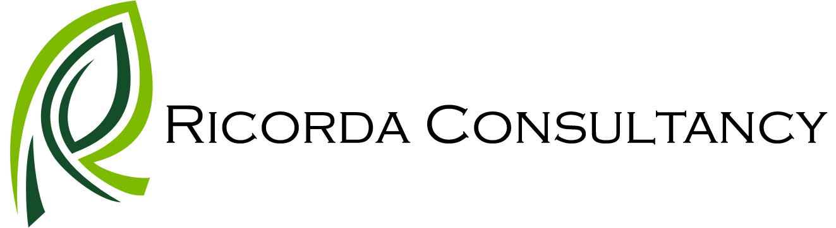**Ricorda Consultancy Ltd**

It is crucial that business put disability back on the agenda. And not just because it’s the 25th anniversary of the DDA but because diversity and inclusion is beneficial to both business and disabled people. There is now substantial evidence that businesses with an inclusive culture perform better, improve market share, have success in new markets, enjoy better retention, and benefit from an improved brand reputation. Diversity and inclusion should not be seen as a tick box exercise but as a key driver in the culture and business model for every organisation.

Talented disabled people who are able to reach their full potential can bring innovation and creative thinking to a business and should be valued for who they are and what they offer.

My business is passionate about people and how they can make themselves and business more successful. We raise awareness of and support the importance of a culture of inclusivity and ‘wellness’ and how it should be at the heart of any business model.

However, many employers are simply not doing enough to support disable employees within their business. Numerous organisations know the importance of healthy and inclusive cultures and often think they are taking steps to address this, but often they don’t really know how to get it right within the context of their own organisation.

Often, organisations implement strategies or do ‘a bunch of things’ but don’t know what works and what doesn’t and can’t measure the benefits. And sadly a few believe that ‘ticking a box’ is enough.

My business works with organisations to help them create and sustain healthy and inclusive cultures in a number of ways including:

• Looking at what they are already doing and identifying the meaningful measures they could be doing specific to their business;

• Executive and leadership development – supporting leaders to improve collaborative leadership and to effectively set the tone, culture, and expectations of the workforce. And to ensure they understand the benefits of building and leading a healthy, inclusive culture within their organisation;

• Improving soft skills for leaders/managers that enables all people to work hard, feel supported, and foster their personal growth. And to be able to identify any potential issues in the workplace and any additional support employees may need.

We also lobby organisations such as the Institute of Directors to promote inclusivity in their campaigns and their leadership training & development programmes.

It is difficult to choose just one Government measure to support removing non-workplace barriers. Certainly, accessible housing, particularly wheel chair adapted would be a real support for young, disabled graduates. And, apart from help with travel costs, a key measure would also be funding/access to loans for those who want to create their own business.



**Maria Coulson**, Managing Director of Ricorda Consultancy, has over 30 years’ experience in the public and private sector. Her mix of industry and consultancy experience means she brings extensive knowledge and insight to clients across a variety of sectors.

**Unilever**

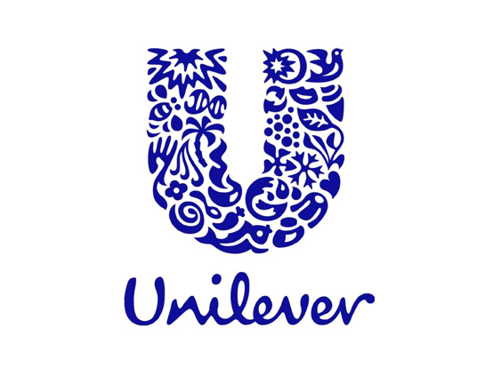

The 25th anniversary of the Disability Discrimination Act is a fantastic opportunity to press for more action on disability inclusion. Not least as we still have much more to do.

The moral case for action is clear: it’s simply not acceptable to leave anyone behind.

But, what’s really interesting is the business case for greater disability inclusion. Today, over one billion people across the world, or 15% of the global population, live with some form of disability. Along with their friends, families and communities they have a disposable income of over $8 trillion a year. That’s an enormous opportunity business simply cannot afford to ignore.

Fortunately, change is already underway, with more and more companies committing to taking an inclusive approach. This includes the launch of ‘Valuable 500’ – a brilliant initiative that asks 500 global businesses to commit to putting disability on their board agendas this year.

This is exactly the kind of action we need. I urge any firm that has not already signed up to do so without hesitation.

Together with gender equality, Unilever has identified disability inclusion as a top priority.

Unilever has many examples in its business across the world where the company is working to provide people with disabilities with more opportunities and support, whether in Egypt, Mexico or South Africa.

In addition, Unilever is also using the power of advertising to change how people with disabilities are perceived and multiple Unilever brands – including Brooke Bond and Dove – have featured people with disabilities in their commercials.

However, Unilever wants to make a more transformational shift. That is why the company has established a ‘Disabilities Inclusion Programme’, to comprehensively change the way it recruits people with disabilities and helps them develop. This includes doing more to promote the hidden talents of people with disabilities, whose perspectives and insights can help Unilever get closer to its customers and connect with consumers.

Demonstrating its commitment to this crucial agenda, Unilever has announced its vision to become the number one employer of choice for people with disabilities by 2025 and to have employees with disabilities representing 5% of its workforce.

The best contribution the government can make is to facilitate bigger investments in technologies that can help people with disabilities.

Rapid developments in automation and connectivity within the transportation industry could, for example, result in a travel and commuting ecosystem that’s very different from what we know today.

The growth in automated vehicles, coordinated ride-sharing, navigation applications, integrated payment systems and other advancements can all make a massive difference in helping people with disabilities get to work.

These are exactly the kinds of advancements we should be embracing and supporting.

**The Valuable 500**

In the last 25 years, progress has been slower than we need it to be. The DDA was a milestone moment, but many organisations are still seeing disability as a requirement to tick mandatory boxes, as opposed to taking full advantage of the opportunities presented by tackling inaccessibility at a deeper level.

25 years on, it’s important for brands and business to assess how their competitors are using insight from disabled consumers and employees to drive innovation and improve experiences for all people. This isn’t about meeting the bare minimum legal requirements; this is about removing barriers for everyone who experiences your brand to ensure you’re engaging with as many people as possible, for as long as possible. This is about seeing inclusivity as a sustainable growth opportunity.

But this kind of shift in mindset needs to come from the top. It is essential that business leaders work to empower their teams by putting disability performance on the board agenda. In the last 30 years, bold business leadership has played a crucial role in driving social change. Now is the time for bold business leadership to do the same for disability inclusion. That’s why The Valuable 500 is calling for 500 of the most influential business leaders and their brands to ignite systemic change by unlocking the business, social and economic value of the 1.3 billion people living with disabilities around the world.

We are seeing an increase in the number of organisations who fully understand the business, brand and social benefits of hiring disabled talent. Virgin Media in particular is heavily invested in creating more job opportunities for disabled people, as seen through their “Work with me” scheme in collaboration with Scope. It is a call to action for businesses to come together to create more inclusive workplaces for disabled people. Virgin Media can’t meet this target alone, so they are asking businesses across the country to act – to come together to change workplaces for good.

Much like Virgin, Sainsbury’s champion disability at board level, having appointed an executive sponsor. This top-down support enables Sainsbury’s to invest in removing environmental barriers in the workplace. The supermarket also profiles their colleagues with disabilities through their role model campaign #thisisme.

Through their accessible hiring journey, Digital Transformation leaders Atos have found that the cost of making a workplace adjustment is 14% of the cost of the recruitment agent fees required to replace that employee. Add to that the additional cost of hiring and training new joiners and it’s clear to see that in the long term, it’s more financially savvy to make life easier for those employees who have bespoke workplace needs.

Brands like Virgin and Atos have confirmed that when they have support from their CEO and board, they are able to invest in removing barriers for employees in a much more meaningful way, right across the hiring process.

As we know, disability is a term that covers a broad spectrum of lived experiences. Identifying just one measure therefore won’t necessarily benefit all disabled graduates. Indeed, a process of acknowledgement and understanding should, first and foremost, be the priority before any investment is made on a practical level. To this end, a nationwide Inclusive Access Audit would be the most prudent and beneficial undertaking to ensure that the generated solutions are fit for purpose and actually make a difference to the lives of disabled people. Only once we have performed a comprehensive Inclusive Access Audit will we truly know the extent of the societal barriers obstructing the lives of young, disabled graduates. Providing the criteria were transparent, consistent and developed with Disabled People’s Organisations, there is no reason why this should not be piloted in specific areas, e.g. a London borough, a Midlands local authority and a rural town, to gain a snapshot of the issues in different settings and the best practice which exists, before rolling the audit out across the country.





1. ONS, Labour market status of disabled people, May 2019
2. Leonard Cheshire 2018
3. Leonard Cheshire/ComRes 2018 Line manager survey.
4. Leonard Cheshire/ComRes 2018 Line manager survey.
5. Leonard Cheshire/ComRes2017