A Better WCA is possible

Online appendix

Ben Baumberg Geiger

School of Social Policy, Sociology and Social Research (SSPSSR), University of Kent

www.benbgeiger.co.uk / b.b.geiger@kent.ac.uk

19th February 2017

In the main report, I present results from a YouGov survey. In this online appendix, I explain the methodology of the survey in more detail.

Table of contents
The survey itself 2
Standard questions 3
The vignettes 6
Transparency & access to the data 11
Bibliography 12

The survey itself
The survey itself was conducted by the polling agency YouGov: 1,973 members of the British public completed an online survey between 28 Feb and 6 March 2017.
YouGov surveys (like most online surveys) are conducted based on an opt-in panel; YouGov’s panel at the time of the research included 450,000 British adults. To make the results representative of the British population for each project, YouGov draws a sub-sample of panel members according to a series of criteria to match known population totals (from the census, official ONS population estimates, 2015 general election & 2016 referendum results, and large-scale random probability surveys). All results quoted in the report use the weights supplied by YouGov.
As I have noted elsewhere (Geiger, in press), “Online panels are increasingly used in social research and generally show similar distributions of political variables to face-to-face surveys using random samples, but we would expect the samples to be slightly skewed towards those with greater political interest/knowledge (Liu and Wang, 2014; Sanders et al., 2007).” For further details, see YouGov’s fuller description of its panel methodology, and their responses to the 28 ESOMAR questions. YouGov’s research is conducted according to Market Research Society guidelines.

Standard questions
The questions that underlie the statements in the text are as follows:

Knowing ‘genuine’ and ‘non-genuine’ claimants
Main text: “while 19 per cent of respondents to the survey said they knew an incapacity benefits claimant who was ‘not genuinely disabled’, noticeably more people – 28 per cent – said they knew someone ‘who is genuinely sick or disabled that has struggled to get the benefits they are entitled to’.”
This uses the questions:
Do you know of any incapacity benefits claimants who you think are **not genuinely sick or disabled**? Please tick all that apply:
No, I do not know any incapacity benefit claimants who I think are not genuinely sick or disabled
Yes - a member of my close family
Yes - a member of my distant family
Yes - a close friend
Yes - a neighbour
Yes - someone else {with a space for a text response}

Now thinking about the opposite situation - do you know anyone who is **genuinely** sick or disabled that has **struggled** to get the benefits they are entitled to? Please tick all that apply:
No, I do not know anyone that is genuinely disabled who has struggled to get the benefits they are entitled to
Yes - a member of my close family
Yes - a member of my distant family
Yes - a close friend
Yes - a neighbour
Yes - someone else {with a space for a text response}

Main text: “more of the public prioritise supporting genuine claimants (45 per cent) than rooting out fraud (22 per cent). This does not mean that people necessarily want a more lenient assessment overall, but that there is a widespread feeling that the WCA does not do a good job, with 56 per cent of people saying that it often makes wrong decisions, and only 10 per cent saying that it assesses who should get benefits accurately (the rest not being able to choose between the statements, or saying they don’t know).
This uses the questions:
Below you see a number of opposite views about the Government's assessment for incapacity benefits (the work capability assessment). How would you place your views on the scale?

0 left "It should be stricter in general"
10 right "It should be easier in general"

0 left "It accurately assesses who should get benefits
10 right "It often makes wrong decisions"

0 left "It is more important to root out fraudulent claimants"
10 right "It is more important to make sure no genuinely sick/disabled people are left
without support"

Main text: “in our survey I asked if two wheelchair users with identical impairments should receive ESA: one was low-educated and unlikely to work, the other was highly educated and could easily get a job. Survey respondents were split in their response, but more people opposed real-world factors than agreed with them: 30 per cent believe that only the low-educated claimant should receive benefits, while 58 per cent thought that both should receive benefits.”
This uses the question:
Imagine two people who have an identical disability and are out-of-work, but have different chances of finding work again:
- Both were in a car accident a couple of years ago, and paralysed from the waist down.
- Dan is 55 years old, and can no longer do his job as a plumber. He has no qualifications and lives in the Welsh valleys where there are few jobs.
- Nick is 25 years old, and is a computer programmer. He has a degree and lives in London, and there are lots of jobs he can still do

Because it now costs them more to get around, they are both likely to get some extra support from government to meet their transport needs. But beyond this, should they receive incapacity benefits while they are out-of-work?

**Plase select the statement that you agree with the most**:
Only Dan (who is unlikely to get a job) should get incapacity benefits
Both Dan and Nick (who can probably get a job) should get incapacity benefits
Neither of them should get incapacity benefits
Other {open text field}

Main text: “most survey respondents said that they would not require people to have a fit note each time their recognised health condition affected them”
As footnote 123 notes, “Respondents were asked, ‘Imagine a benefit claimant that the Jobcentre knows has a diagnosed health condition. They have not turned up to a meeting at the Jobcentre, and don’t have a doctor’s note for that day because they say they weren’t feeling well enough to go to the doctor. Should they have their benefits cut or stopped because they don’t have a doctor’s note?’ Only 22 per cent said their benefit should be cut in this situation, whereas 56 per cent said they should not be.”

The vignettes
Rather than asking about ‘disabled people’, where it is hard to know exactly what is in the public’s mind, I used a variety of fictional pen-portraits – ‘vignettes’ – of different types of disabled people. To understand which factors influence the public’s responses, I varied several different characteristics of the vignettes at the same time. This means that each person will have seen a slightly different set of vignettes, but because these different characteristics were given to people at random, we can tease apart the role of each characteristic.

How the vignettes looked
All of the vignettes had the following structure:
The description below is about someone who is applying for out-of-work benefits – after you have read it, we will ask for your views about this person’s situation.

- Liz is 60, and has often been unemployed, though 2 years ago she was working
- However, 5 years ago she left her job because she said she had the following:
- Started mostly feeling heavy and joyless, finding it difficult to get out of bed
- Can’t cope with unexpected changes (e.g. changing an appointment at short notice)
- Can still get to new places on her own, but can’t usually speak to new people
- Her doctors have signed a sick note for her & diagnosed her with depression
- Liz can't do her previous line of work. She has no qualifications, and can't think of any employers locally who would now employ her

Each respondents was asked 2-3 vignettes in this format. Each of the elements of each vignettes was randomly varied to enable us to see how important each characteristic is, as I now describe.

The vignette characteristics

Symptoms/impairments
Symptoms/impairments 1:
o Was in a severe car accident, and now has severe pain in his back and legs
o Can’t walk 100m in one go, or raise either arm above head height, or lift light bulky objects
o Finds it hard to concentrate, but can still stay sitting down for a while and use a keyboard/mouse
Symptoms/impairments 2:
o Has been overweight all his life, and now has severe pain in his back and legs
o Can’t walk 100m in one go, or raise either arm above head height, or lift light bulky objects
o Finds it hard to concentrate, but can still stay sitting down for a while and use a keyboard/mouse
Symptoms/impairments 3:
o Was in a severe car accident, now has no feeling at all in his body from the chest down
o Can use his arms as normal, but uses a thin tube ('catheter') to empty his bladder during the day
o Can get around easily using a wheelchair to anywhere that is wheelchair-accessible
Symptoms/impairments 4:
o Started mostly feeling heavy and joyless, finding it difficult to get out of bed
o Can’t cope with unexpected changes (e.g. changing an appointment at short notice)
o Can still get to new places on his own, but can’t usually speak to new people
Symptoms/impairments 5:
o Suffered the trauma of the death of his son
o Started hearing voices even though no one else was around, which told him what to do and think
o Almost never leaves his home, and has been thinking about committing suicide
Symptoms/impairments 6:
o Was drinking heavily and sometimes taking illegal drugs
o Started hearing voices even though no one else was around, which told him what to do and think
o Almost never leaves his home, and has been thinking about committing suicide
Symptoms/impairments 7:
o Started feeling in pain across several different parts of her body
o Finds it difficult to sleep, feels tired most of the time, and can't think straight
o The pain stops him from moving around or doing everyday tasks around the house

Other characteristics
Role of doctors – sick note/diagnosis:
• He does NOT have a sick note from his doctor
• His doctor has signed a sick note for him, but has not been able to confirm a diagnosis
• His doctor has signed a sick note for him & diagnosed him with [condition]

The conditions are (in the same order of the symptoms/impairments presented above):
sciatica & dorsalgia / sciatica & dorsalgia / paraplegia / depression / schizophrenia / schizophrenia / fibromyalgia.
How long ago:
• ‘5 years ago’
• ‘12 months ago’
Work capacity:
• [name] can't do his previous line of work. He has no qualifications, and can't think of any employers locally who would now employ him
• [name] can't do his previous line of work. He has no qualifications, and the Jobcentre can't think of any jobs he could still do
• [name] can't do his previous line of work. While he has no qualifications, the Jobcentre can think of other sorts of work he could do
• [name] can't do his previous line of work. However, he has a degree, and can think of other sorts of work he could do
Work history
• … has often been unemployed, though [2 years ago] he was working
• …has worked all his adult life [so far]
Age
• Age 25
• Age 45
• Age 60
Gender (name)
• [Male] John / Steve / Mike
• [Female] Liz / Sally / Kath

The questions asked after each vignette
The questions used in the report are as follows:
In your opinion, does [name] **deserve** to receive support from the Government while [he/she] is out-of-work?
0 - Definitely does **not** deserve support
to
10 - Definitely **does** deserve support
Don't know

At the moment, do you think [name] would receive incapacity benefits? Please use the scale below where 0 means "Definitely would **not** get incapacity benefits" and 10 means "Definitely **would** get incapacity benefits?
0 - Definitely would **not** get incapacity benefits
5 - Not sure
10 - Definitely **would** get incapacity benefits

If [name] does each of the following, roughly how much do you personally think [his/her] benefits **should** be cut?
-Sometimes turns up late for meetings at the Jobcentre
-Refuses to do suitable training or rehabilitation
-Doesn't apply for a job as [he/she] **disagrees** with the Jobcentre that [he/she] is capable of doing it
[Response categories]:
Not cut at all
Lose a small amount (10%)
Lose a moderate amount (25%)
Lose half of benefit
Lose most of benefit (75%)
Lose almost all of benefit (90%)
Lose all of benefit
Don't know

How easy or difficult would it be for [name] to get a job if they wanted one? Please use the scale below where 0 means "Impossible to get a job" and 10 means "Very easy to get a job".
0 - Impossible to get a job
10 - Very easy to get a job
Don't know

The figures given in the main report
In the main report, I try to present the results in the simplest way possible (I will return to a more complex analysis of the vignettes in forthcoming academic papers). This means that I refer only to a given set of symptoms/impairments – e.g. ‘a wheelchair user’ (symptoms/impairments #3 above).
So for example, when talking about the public’s support for sanctioning (Table 3), I compare a wheelchair user with someone who has depression, both of whom have a medical diagnosis and sick note – the table is duplicated below:
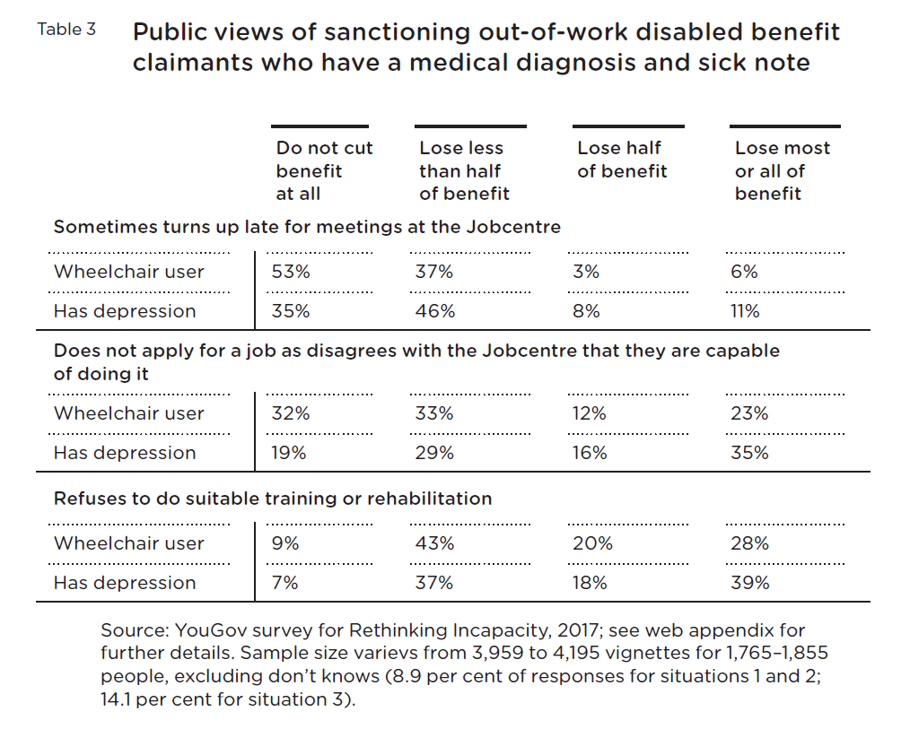
These results are all averaged across all of the other characteristics – that is, averaged across gender, age, duration of their symptoms/impairments, their work history, and their capacity to work. In the rest of the report, I similarly present people’s opinions split by symptoms/impairments and averaged across all of these other characteristics.
The only other use of the vignettes is when I say, “…work capability was discussed at length in focus groups when considering whether people deserve incapacity benefits, and among survey respondents there is a strong relationship between seeing claimants as deserving of benefits and seeing them as capable of working.” The use of the vignettes is explained in the footnote.

Transparency & access to the data
As I say on my website (http://www.benbgeiger.co.uk/publications.htm#peer_reviewed), I am committed to reproducibility and transparency in social science research. However, I need to first have a chance to write academic papers using the survey, before then sharing the data and code with others! Please get in touch if you would like to use the data and gain access to my code (in the statistics program Stata), and I will contact you later in 2018 when this becomes available.

Bibliography
Geiger, B. (in press). Benefit ‘myths’? The accuracy and inaccuracy of public beliefs about the benefits system. Social Policy & Administration
Liu, M., and Wang, Y. (2014). Data collection mode effects on political knowledge. Survey Methods: Insights from the Field. Retrieved from http://surveyinsights.org/?p=5317
Sanders, D., Clarke, H. D., Stewart, M. C., and Whiteley, P. (2007). Does mode matter for modeling political choice? Evidence from the 2005 British Election Study. Political Analysis, 15(3), 257-285

In this project, the quota were: 1. ‘Age’ interlocked with ‘Gender’ and ‘Level of education’ 2. ‘Political attention’ 3. ‘Social grade’ 4. ‘Vote in the 2015 General Election’ combined interlocked with ‘Region’
Via a hyperlink (as well as at the start of the questionnaire), ‘incapacity benefits’ was clarified as follows: “By ‘incapacity benefits’, we mean benefits paid to working-age people who are not working because of long-term sickness or disability ('ESA'). We are not asking about benefits that cover disabled people's extra costs of travel or other everyday activities ('PIP' or 'DLA').” The same hyperlink was available wherever ‘incapacity benefits’ was mentioned.
Footnote 16 in the text: “When survey respondents were asked before the April 2017 cut in generosity (see chapter 2) if they thought the system should be stricter or easier in general, the most common response was that it should be stricter, but only just over one-third (37 per cent) of people said this (28 per cent thought no change, 19 per cent thought it should be easier, and 15 per cent didn’t know).” The footnote then continues with the statistics from the survey that are described just below in this appendix.
More formally: for the sanctioning question
More formally: these are based on multinomial logit models where the outcome is the amount of sanctioning that people support (in four categories, as in Table 3), and the explanatory variables are the different dimensions of the vignettes. I then look at the average marginal effects of each set of symptoms/impairments for people who have a medical diagnosis & sick note.
These are however done in a simpler way, just looking at the percentages of people that give different answers when given different sets of symptoms/impairments (without the statistical model that underpins Table 3). For example, in the main text footnote 16: “…the public don’t seem to have a clear idea of how strict the WCA actually is. I gave people vignettes describing particular types of claimants and asked them if they would currently be eligible for ESA. Large numbers of people (36–43 per cent) said they simply didn’t know if this person was eligible for ESA, and those who answered were often wrong. This was most striking for a vignette of a wheelchair user, where 52 per cent wrongly thought the applicant would be eligible for ESA (only 9 per cent correctly thought they would not). In contrast, 20–29 per cent of people thought that someone with severe back or leg pain would not be eligible for ESA, only slightly below the number who correctly thought they would (30–36 per cent). (They were described in a way that would place them in the WRAG.)”
Footnote 42 in main text: “For each vignette, respondents were asked, ‘Does [name] deserve to receive support from the government while [he/she] is out of work?’ and ‘How easy or difficult would it be for [name] to get a job if they wanted one?’ These were moderately strongly correlated (r=0.48), and many of the characteristics of the vignettes had a similar impact on both (eg the symptoms that people reported, their age, gender, and how long their symptoms have lasted). However, whether people were to blame for their condition (through obesity or addiction) had a much stronger influence on perceptions of deservingness than work capability, as did whether they had been diagnosed by a doctor, and their recent work history (see also below). Conversely, having a degree was more likely to raise a person’s perceived chance of working than reduce their deservingness of receiving benefits.”

